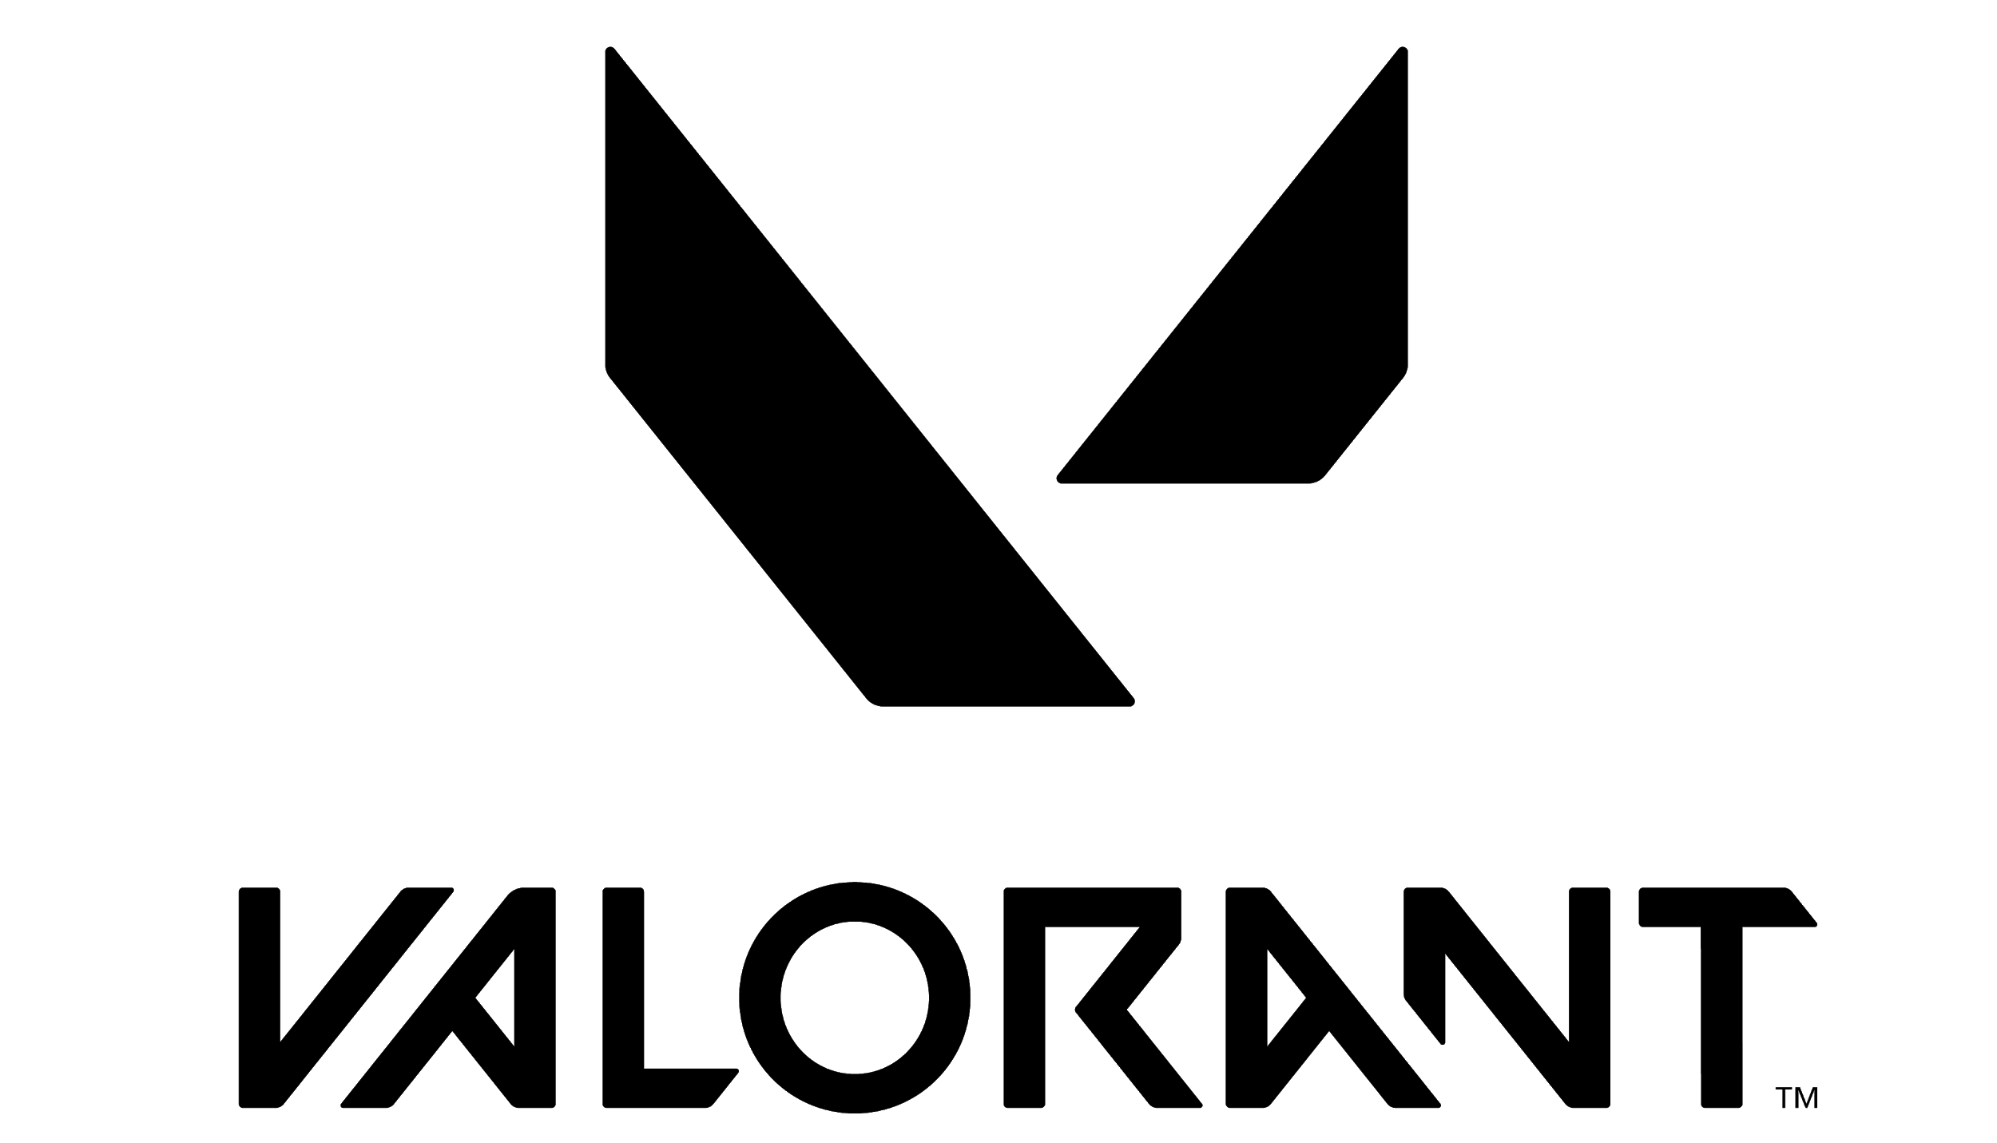

FACT SHEET - PEARL

Product Description
Pearl is our 8th map and first one set on Omega Earth. There are no mechanics like teleporters, ascenders or doors, just a three lane map with small mid and long range wings. It’s also underwater!

Key Features
- Underwater
- 3 lane map
- Attackers descend into Defender territory
- Set in Omega Earth
- Features murals from actual Portuguese muralists
- Features a traditional piece of Portuguese music, a fado, from Portuguese artists

Release Date: June 22, 2022

